

**Batch: B–1 Roll No.: 16010422234 Experiment No.: 07**

**__________________________________________**

**Title:** Monitor performance of existing algorithms using Cloud Analyst

**__________________________________________**

**Resources needed: Cloudsim toolkit**

**__________________________________________**

**Theory:**

There are several extremely good toolkits that can be used to model a simulated environment to study the behavior of a large scaled application on the Internet. But it became apparent that having an easy to use tool with a level of visualization capability is even better than just a toolkit. Such a tool separates the simulation experiment set up exercise from a programming exercise and enables a modeler to concentrate on the simulation parameters rather than the technicalities of programming. It also enables the modeler to execute simulations repeatedly with modifications to the parameters quickly and easily. A graphical output of the simulation results enables the results to be analyzed more easily and more efficiently and it may also help in quickly highlighting any problems with the performance and accuracy of the simulation logic.

**Technologies used to develop cloud analyst tool**

* Java – The simulator is developed 100% on the Java platform, using Java SE 1.6.
* Java Swing – The GUI component is built using Swing components.
* CloudSim – CloudSim features for modelling data centers is used in CloudAnalyst.
* SimJava – Sim Java is the underlying simulation framework of CloudSim and some features of SimJava are used directly in CloudAnalyst.

**Simulation Output / What is being Measured**

Following are the statistical measures produced as output of the simulation in the initial version of the simulator.

* Response time of the simulated application
* Overall average, minimum and maximum response time of all user requests simulated o The response time broken down by user groups, located within geographical regions
* The response time further broken down by the time showing the pattern of change over the duration of a day
* The usage patterns of the application o How many users use the application at what time from different regions of the world, and the overall effect of that usage on the data centers hosting the application
* The time taken by data centers to service a user request o The overall request processing time for the entire simulation o The average, minimum and maximum request processing time by each data center o The response time variation pattern during the day as the load changes
* The cost of operation

**Results: Attach the snapshots of execution**

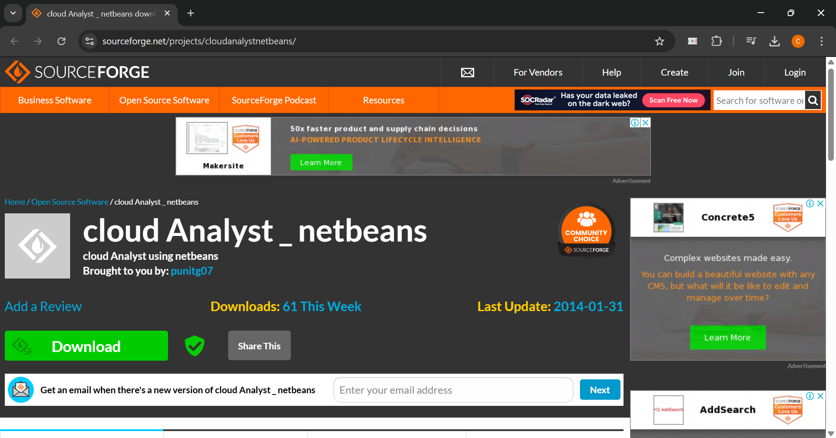

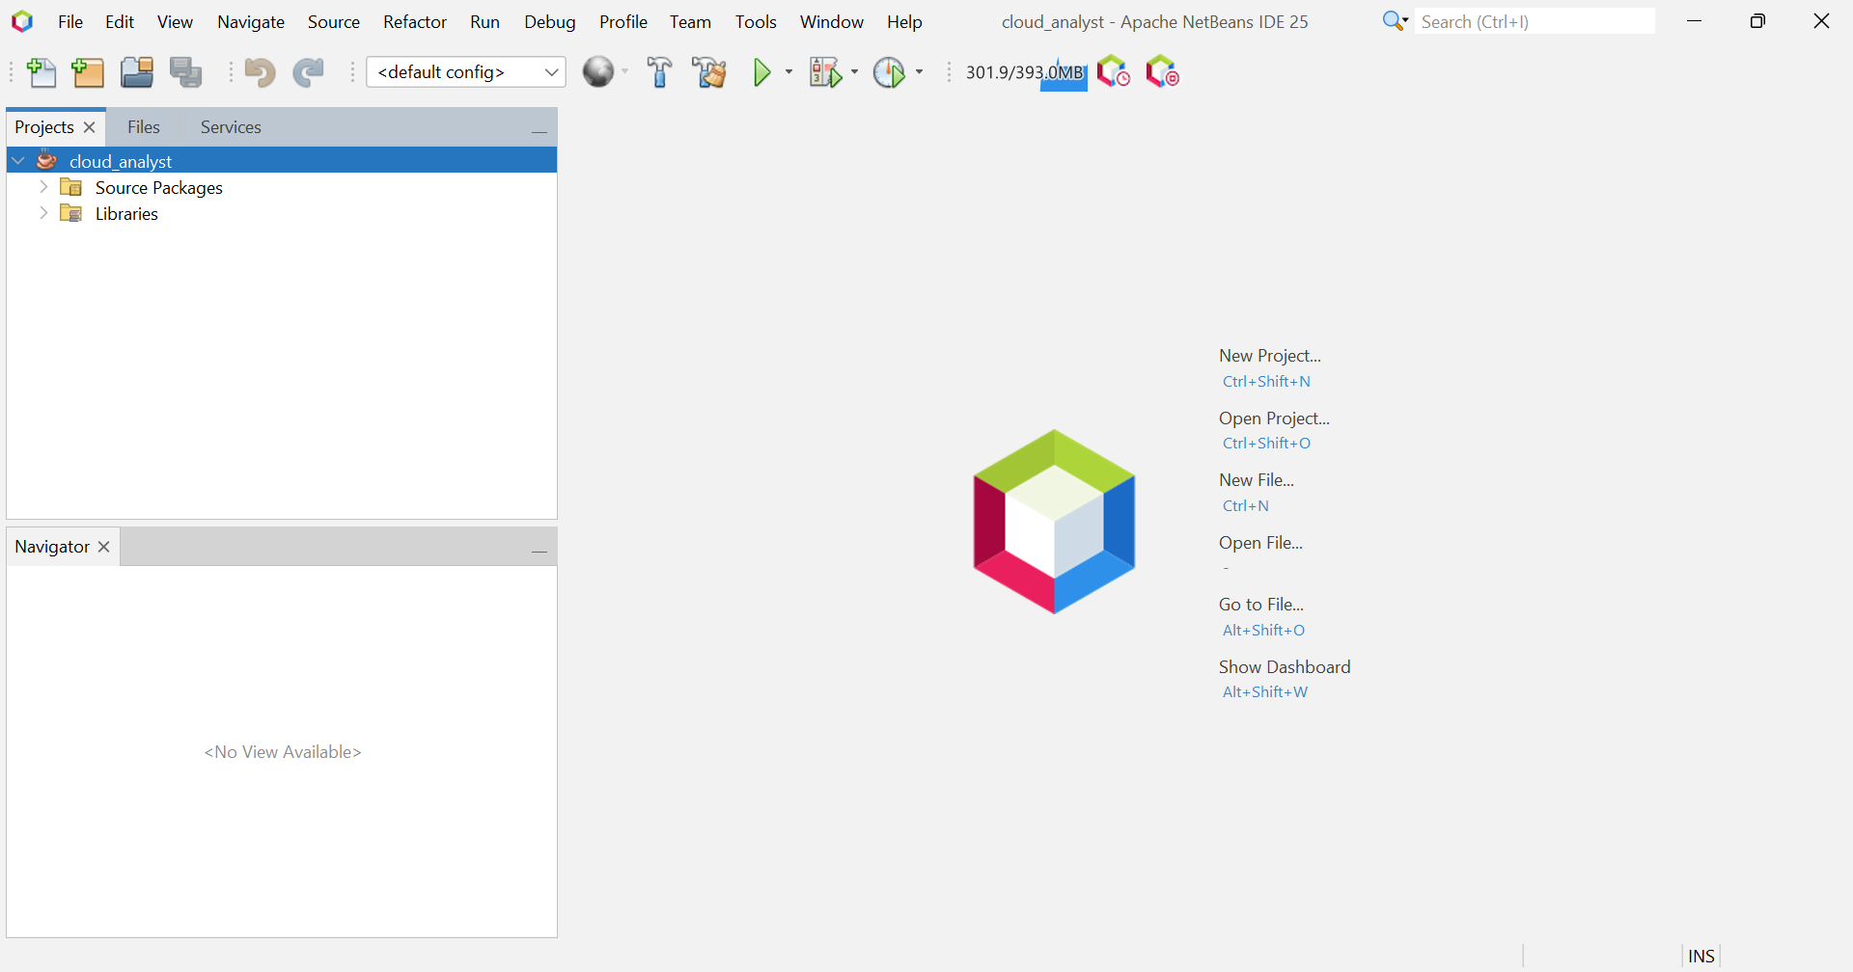

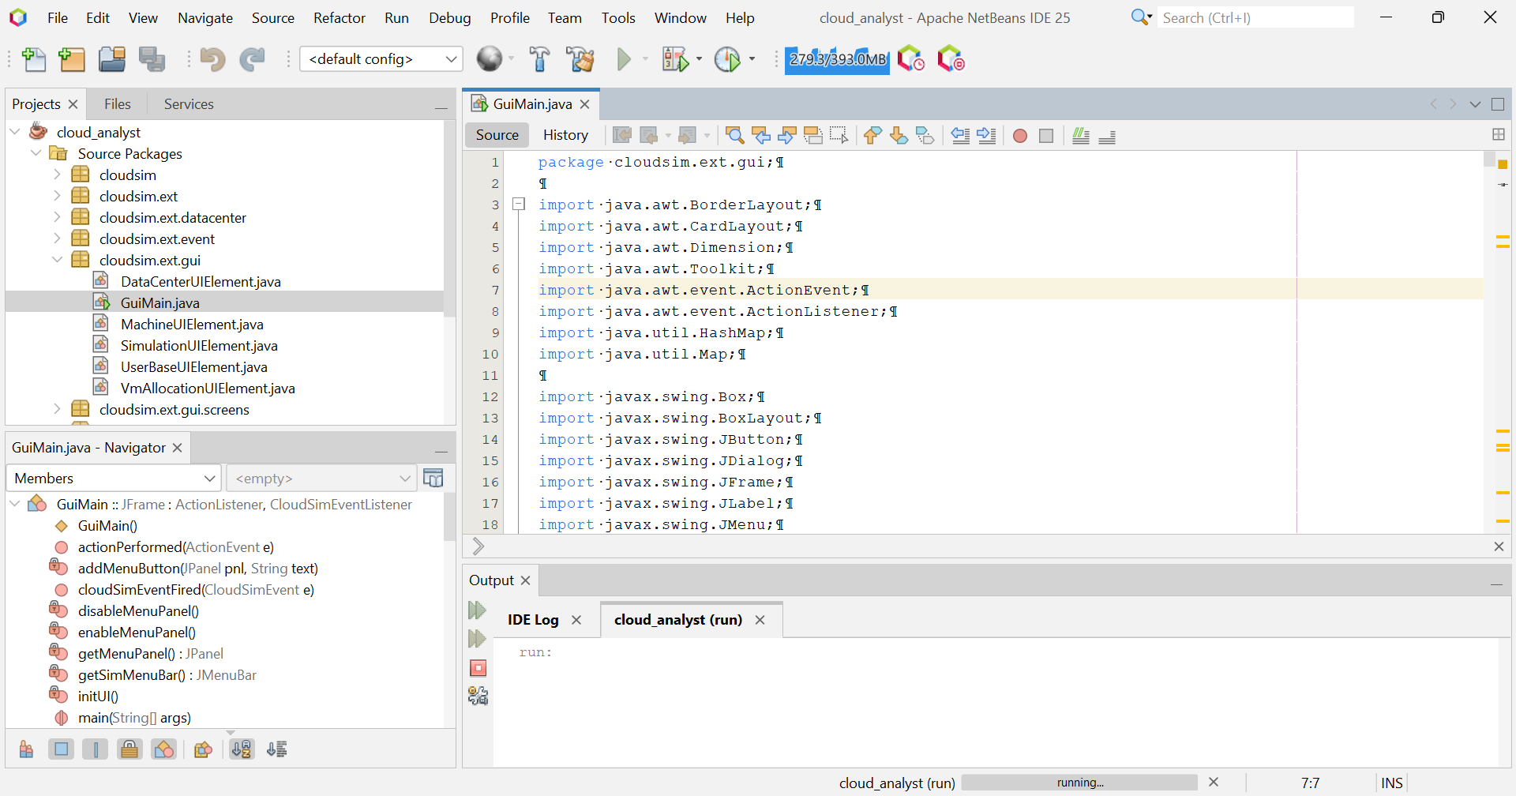

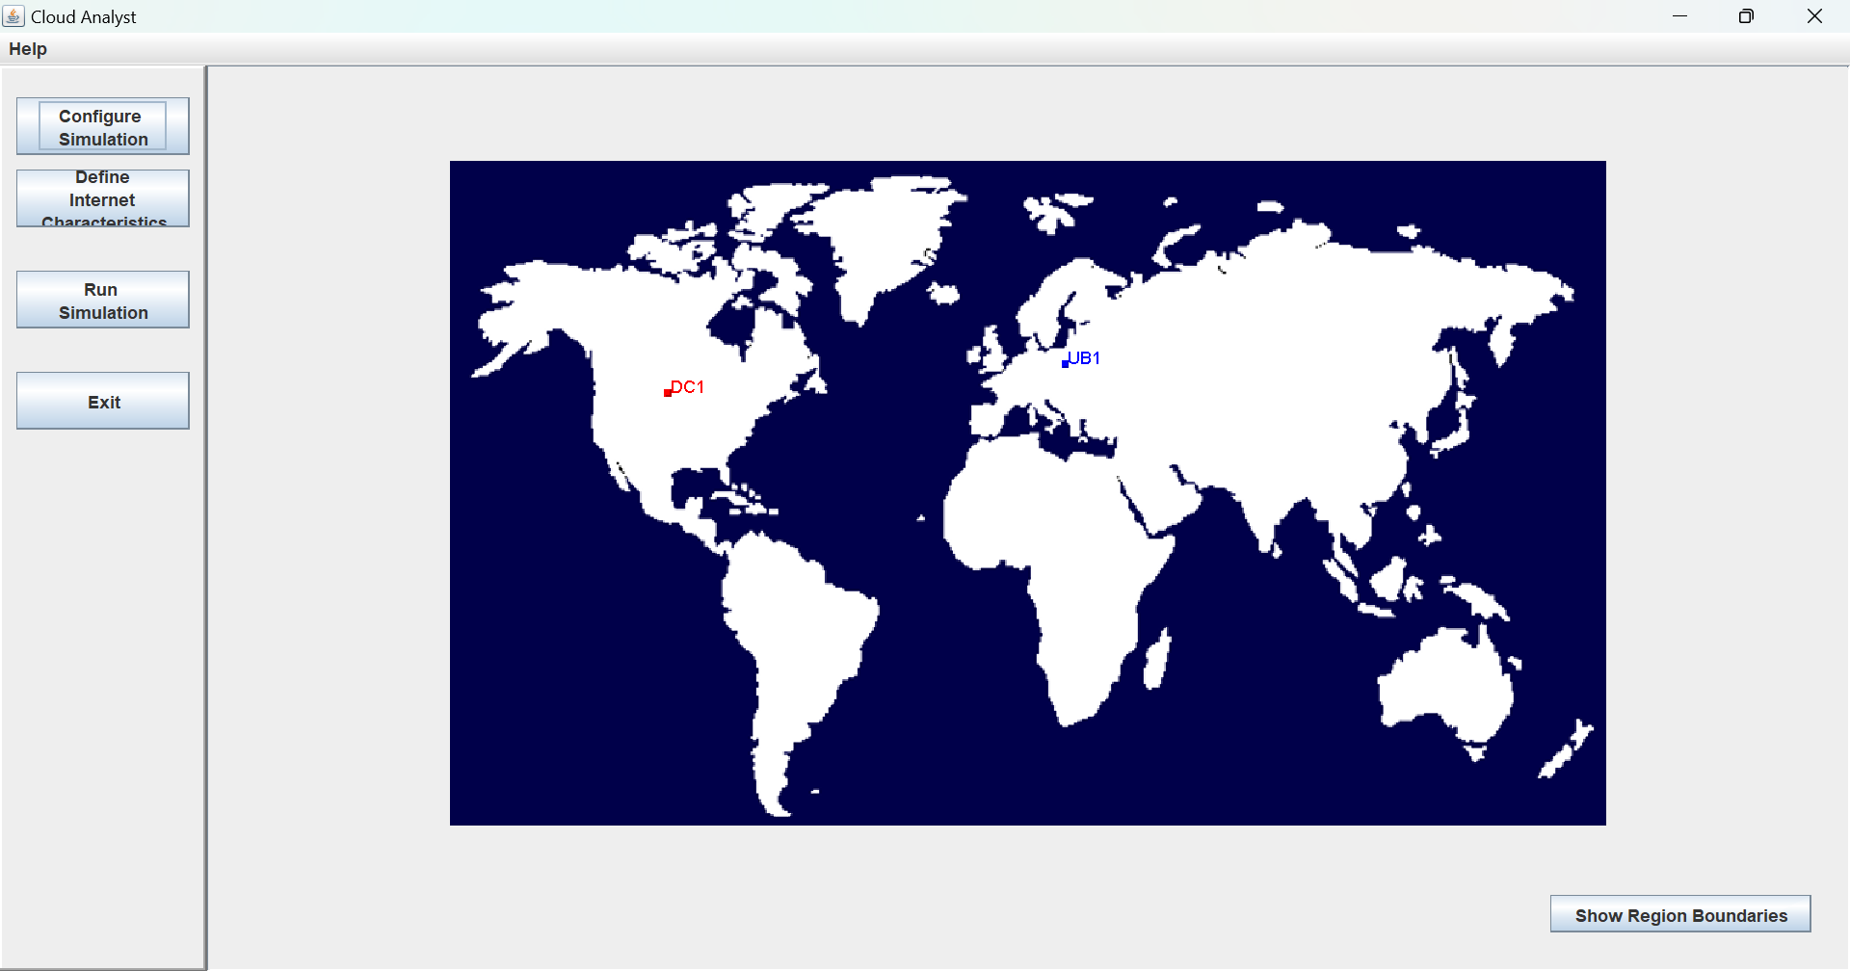

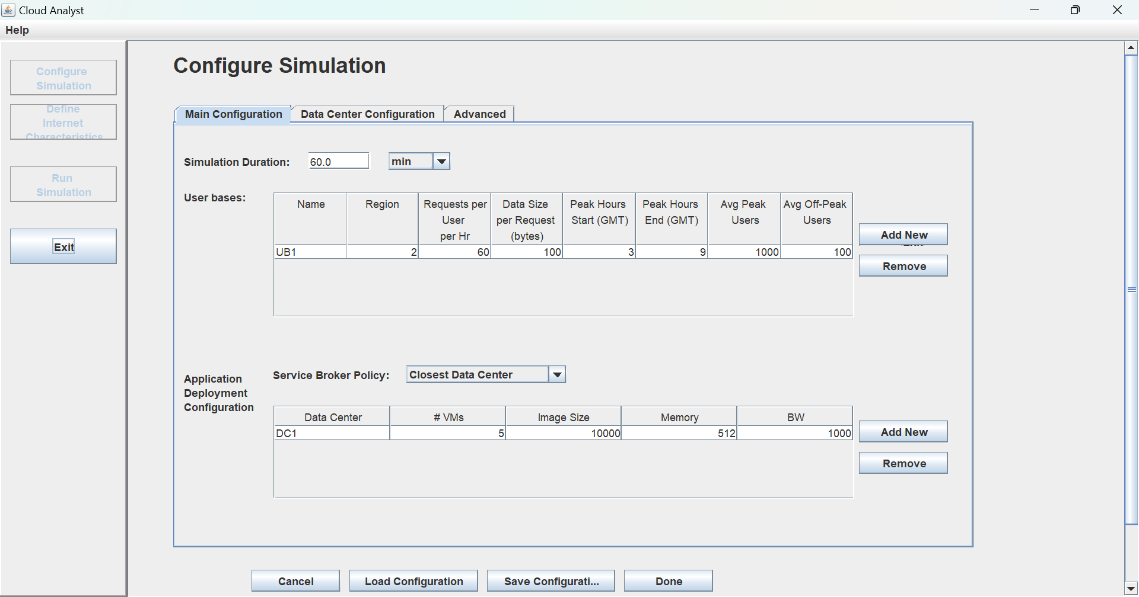

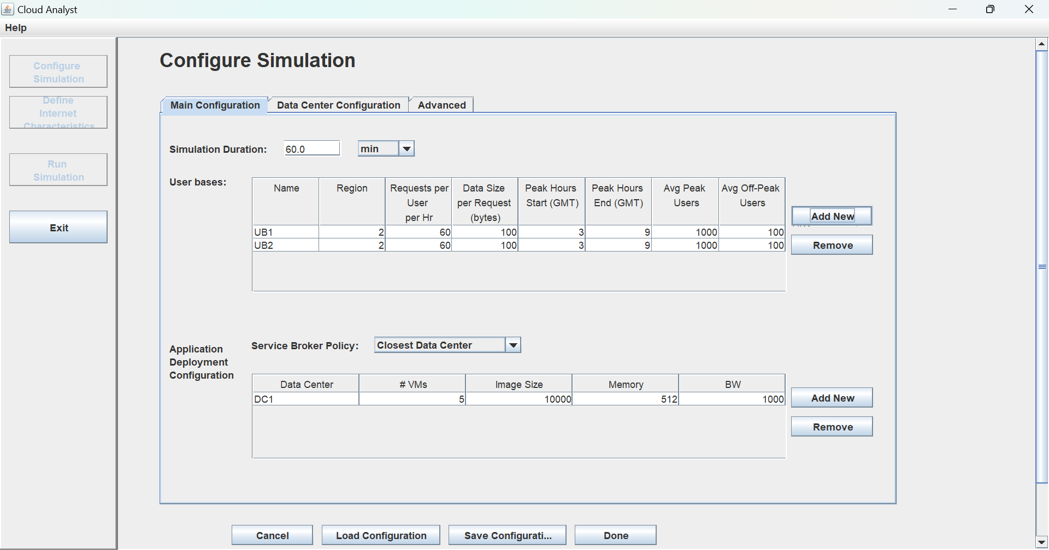

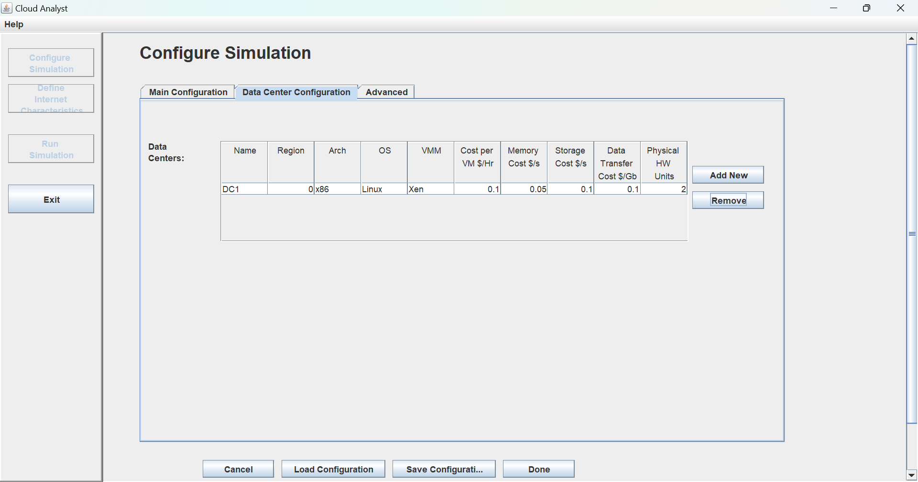

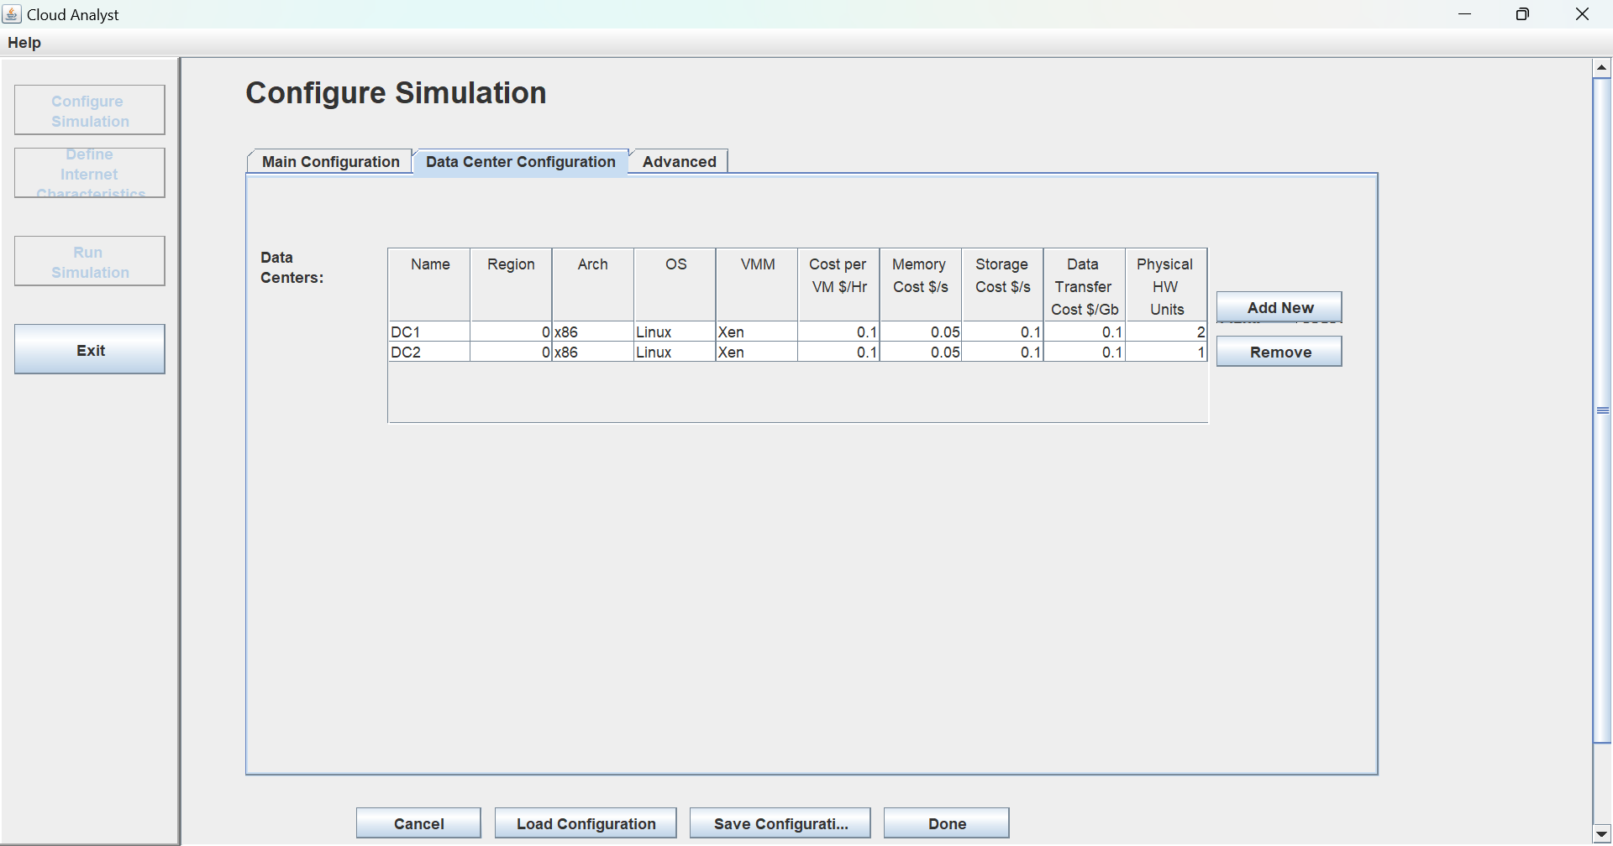

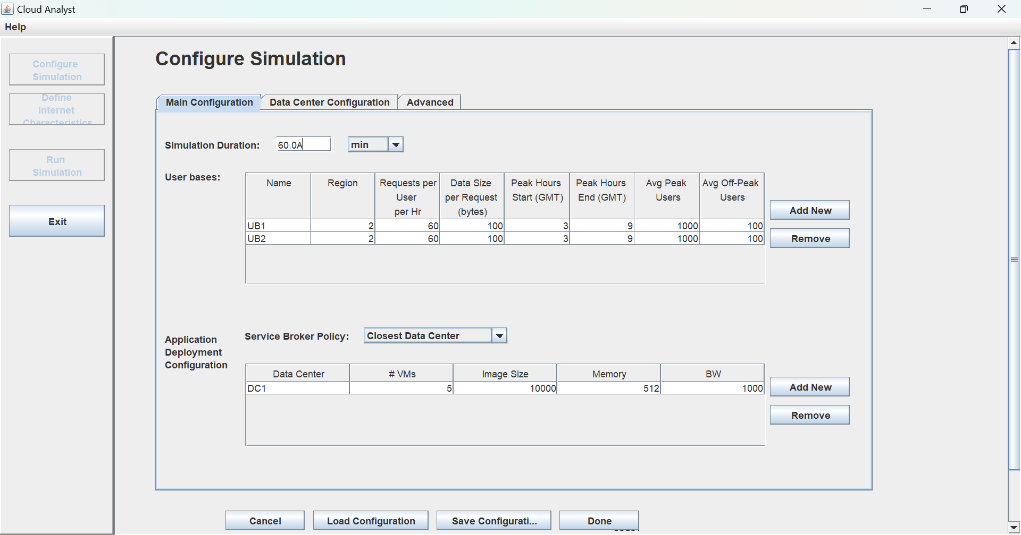

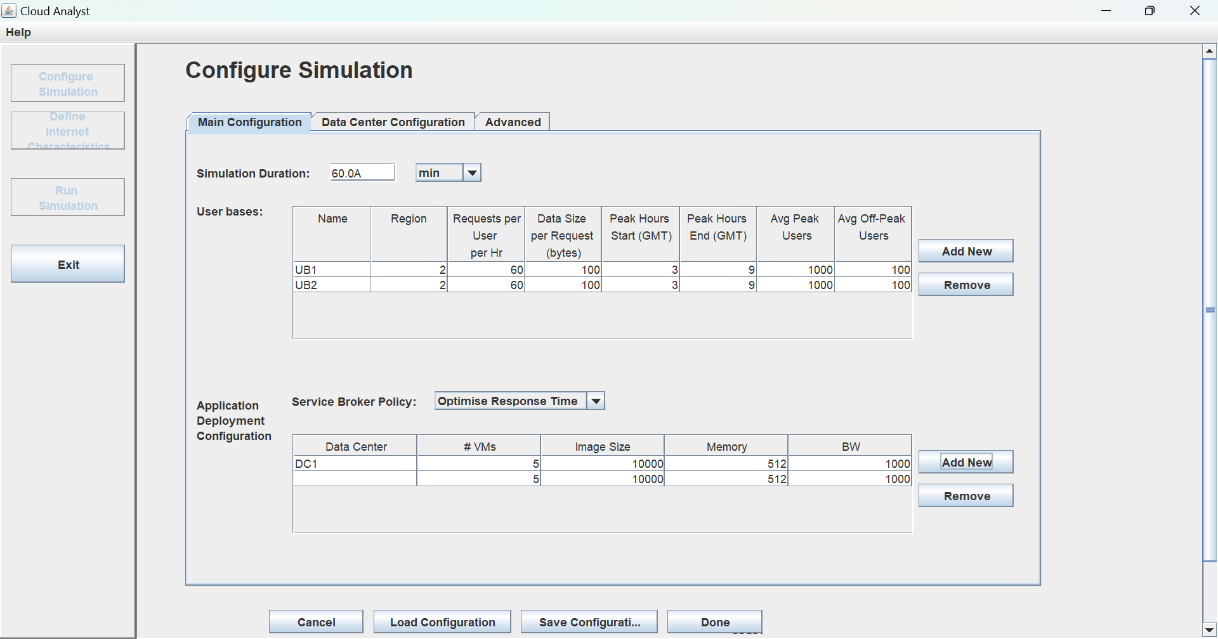

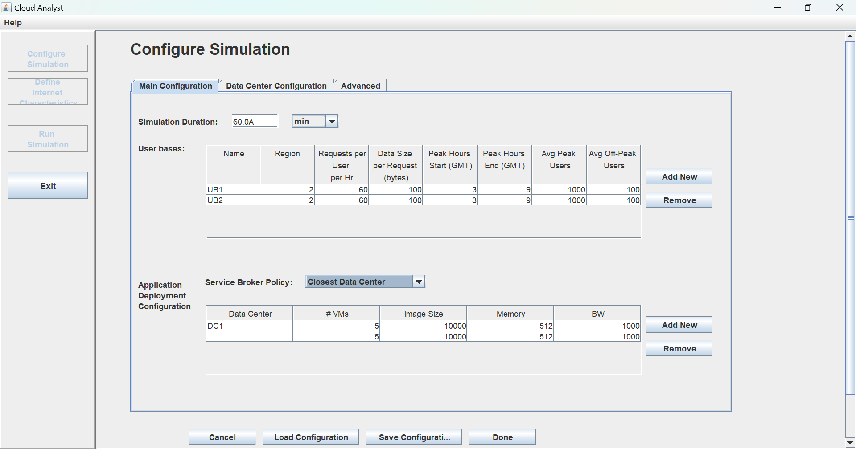

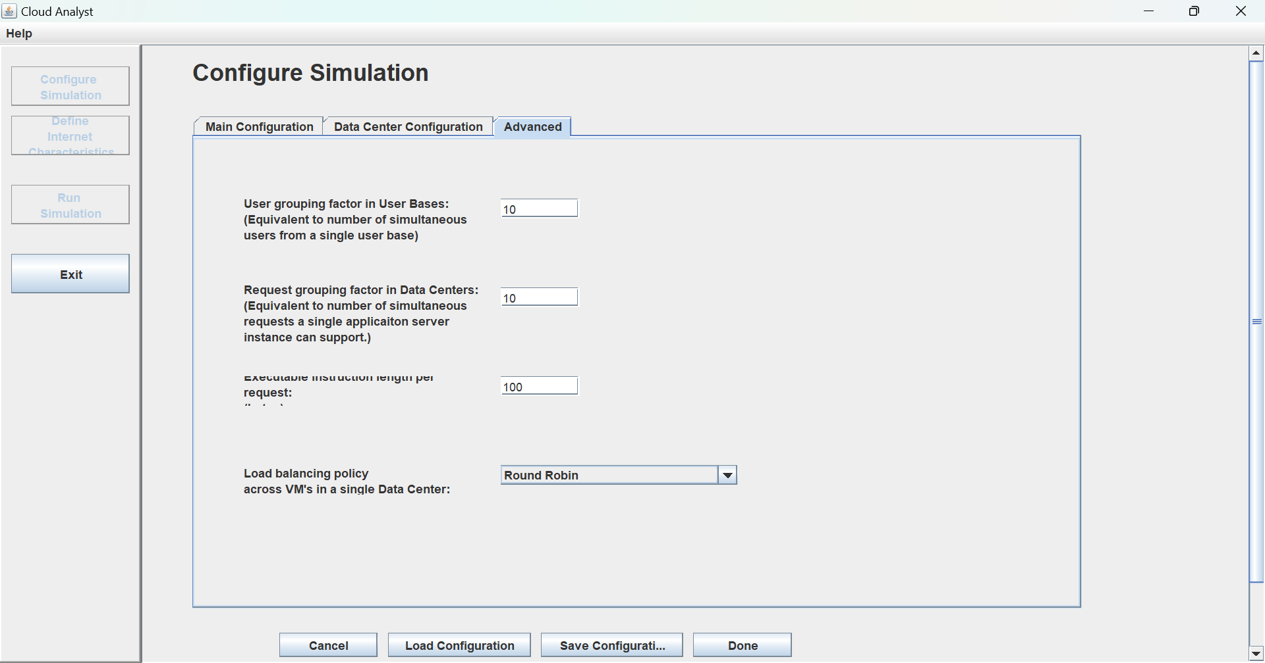

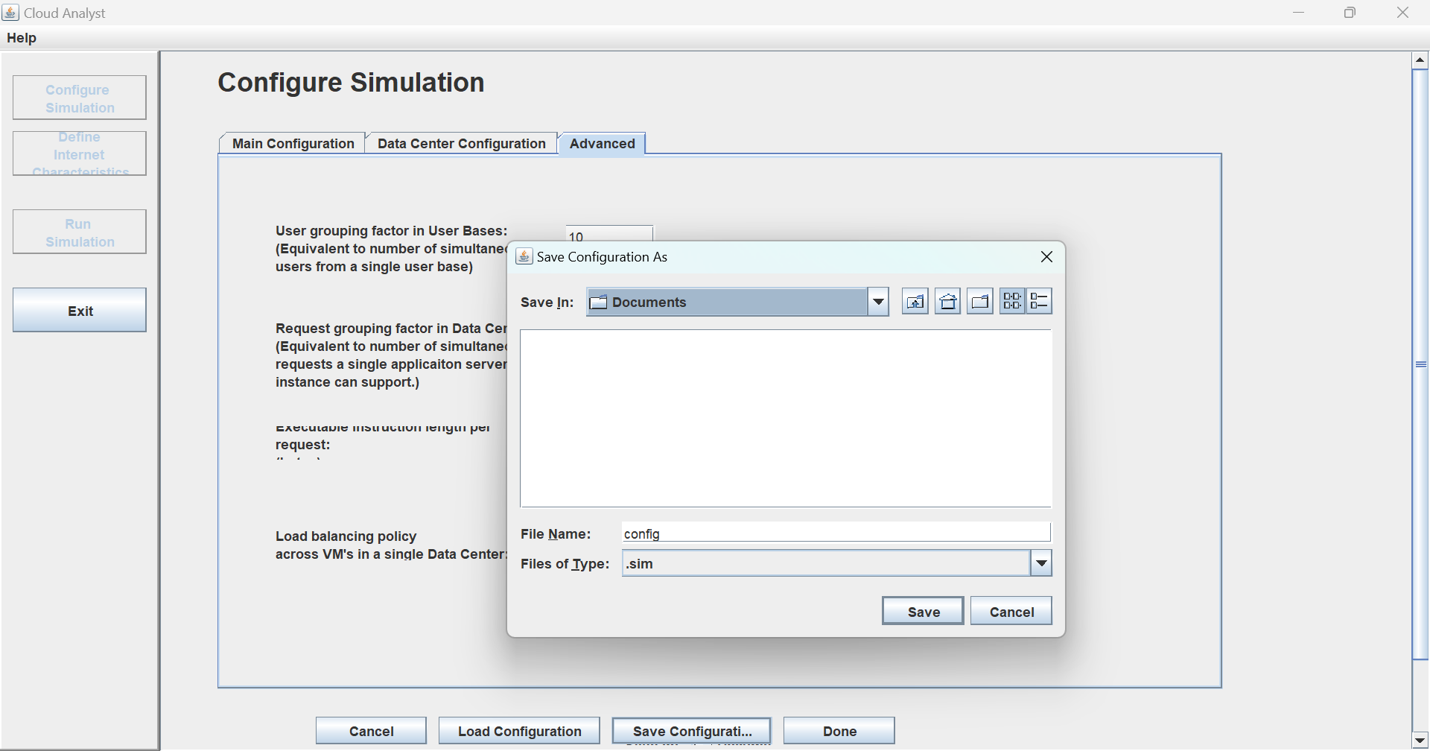

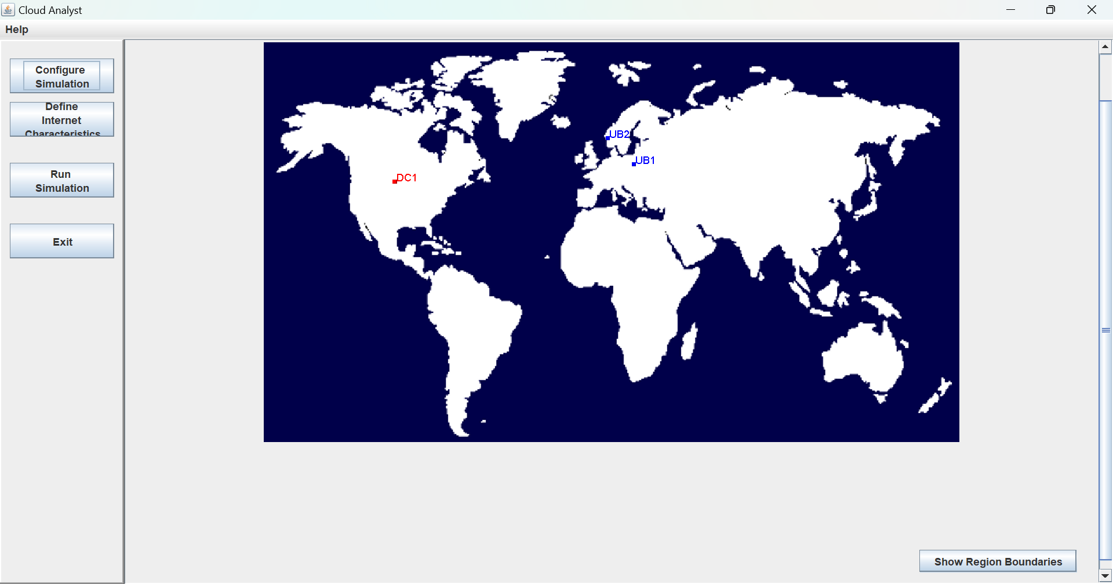

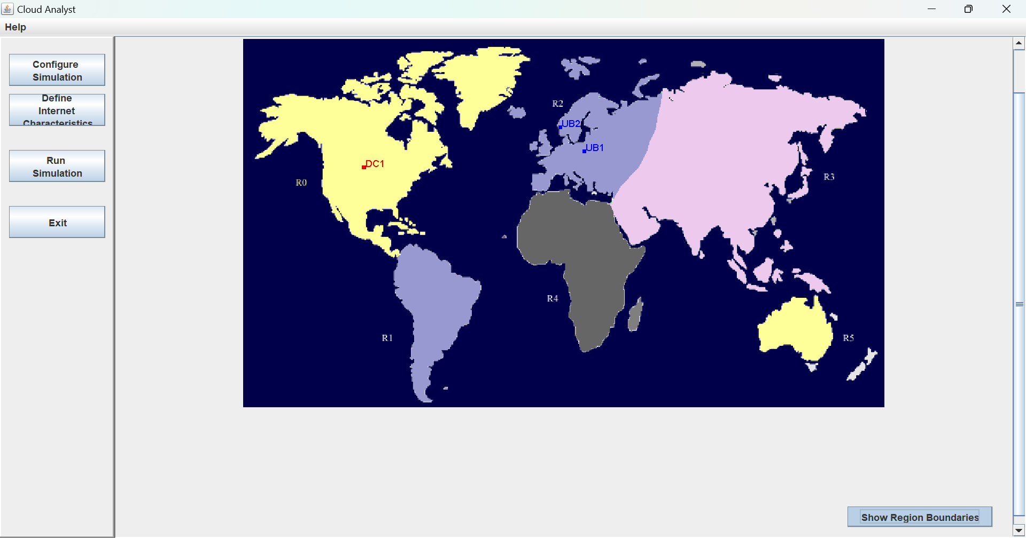

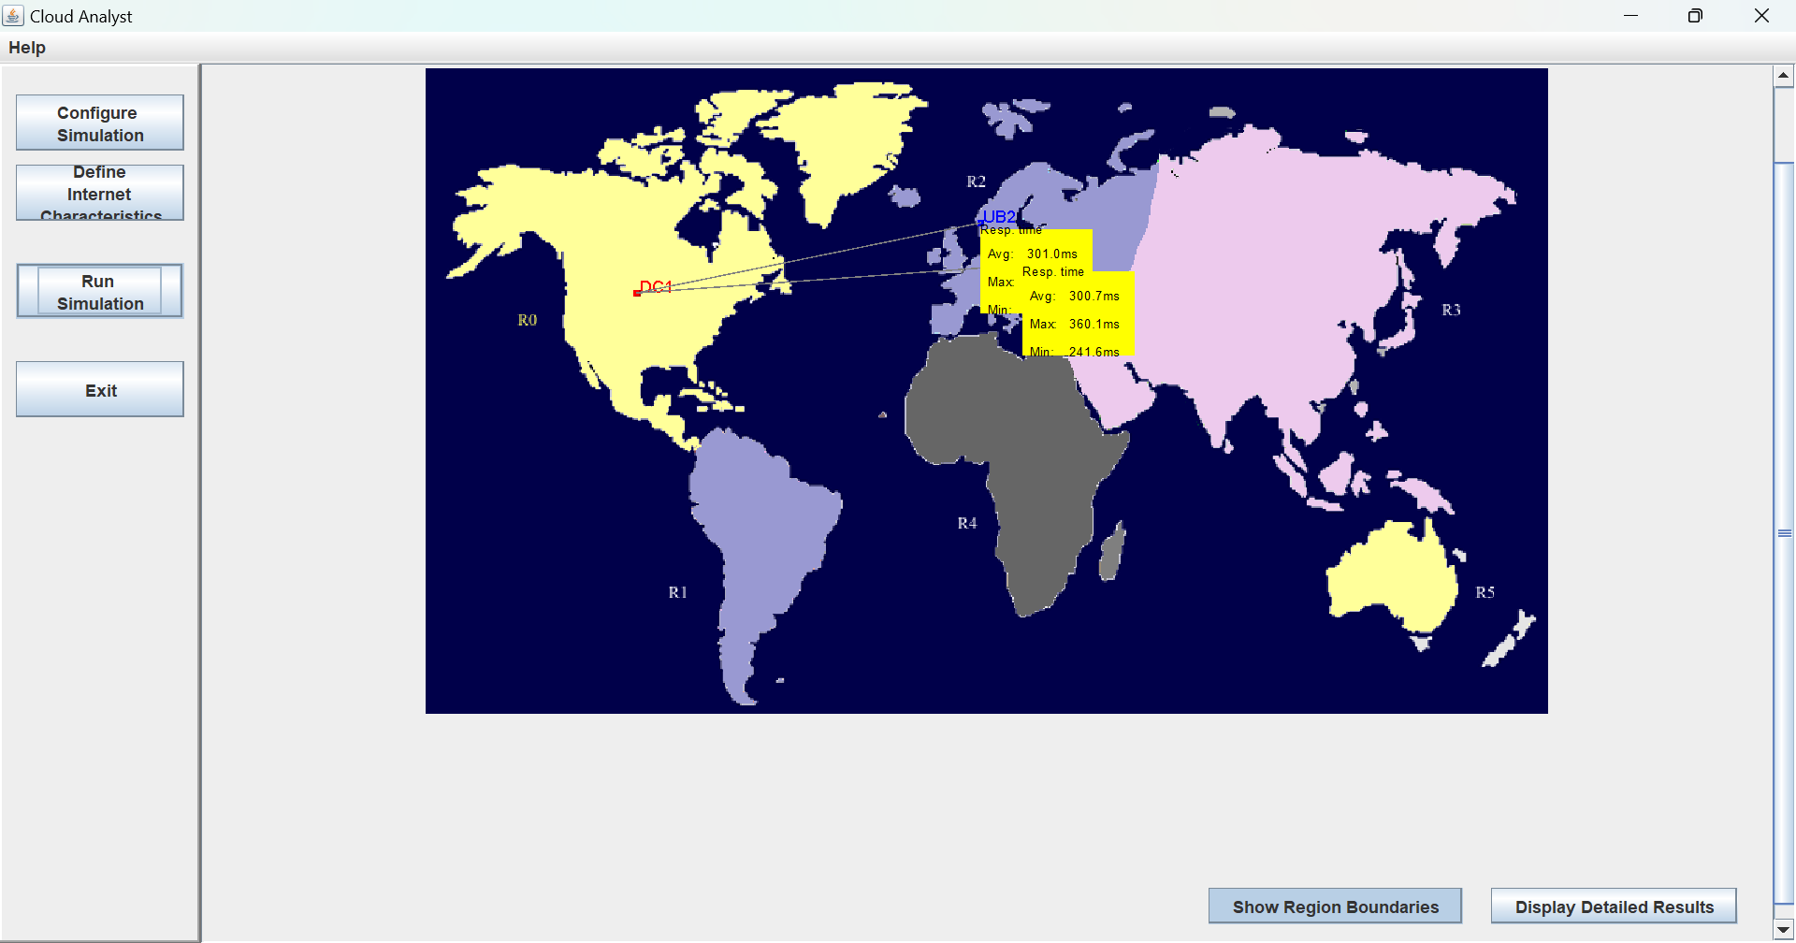

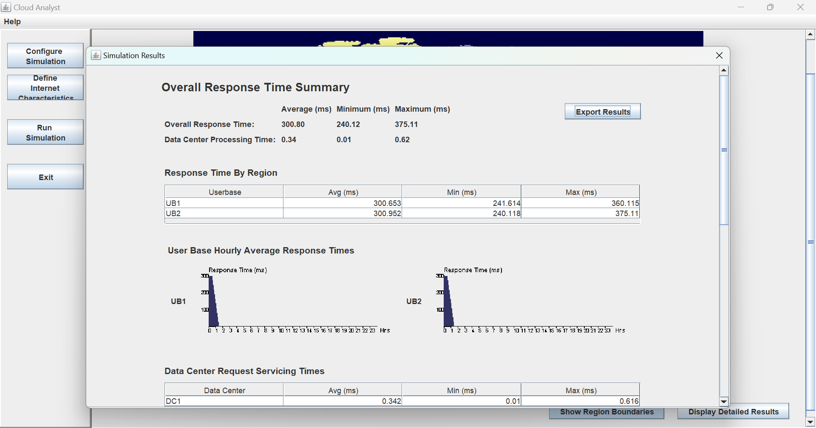

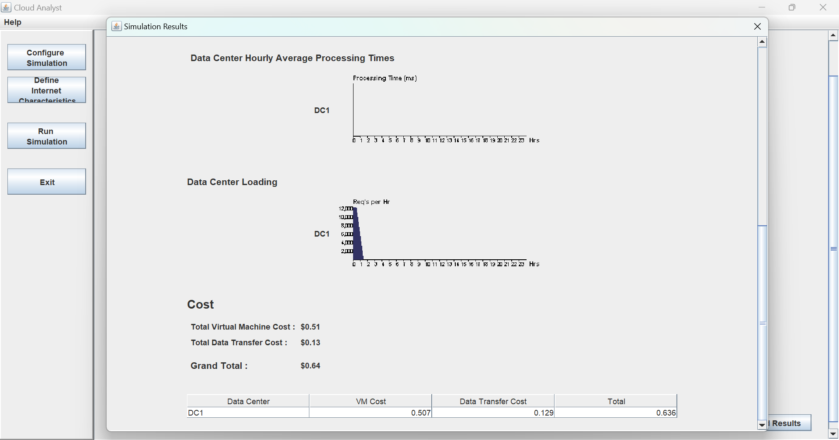

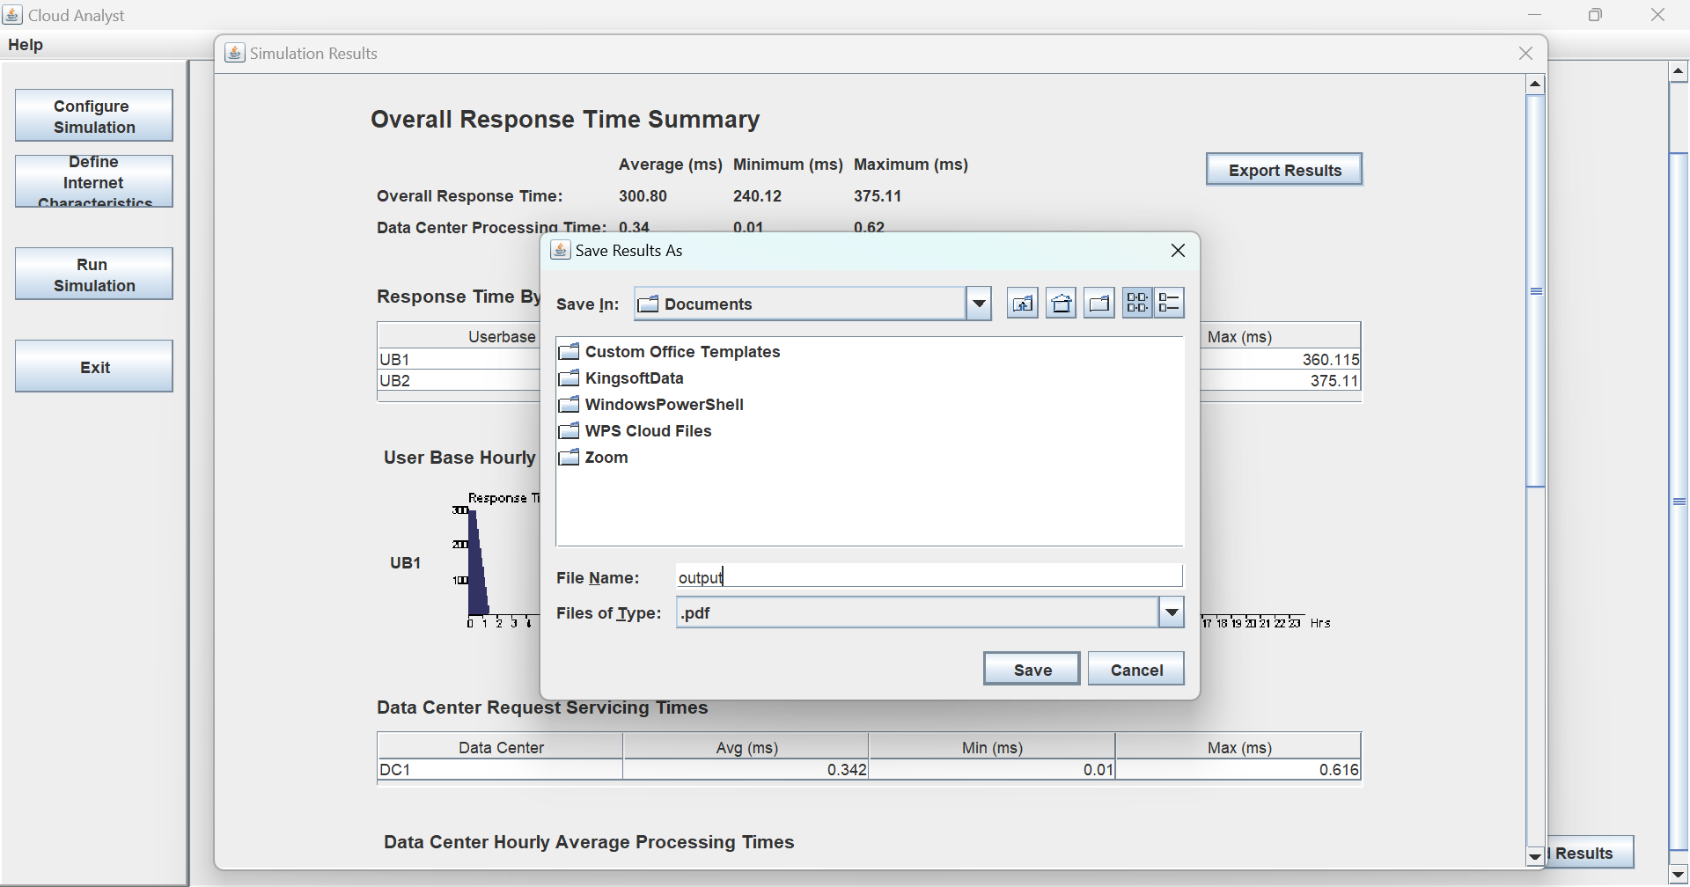

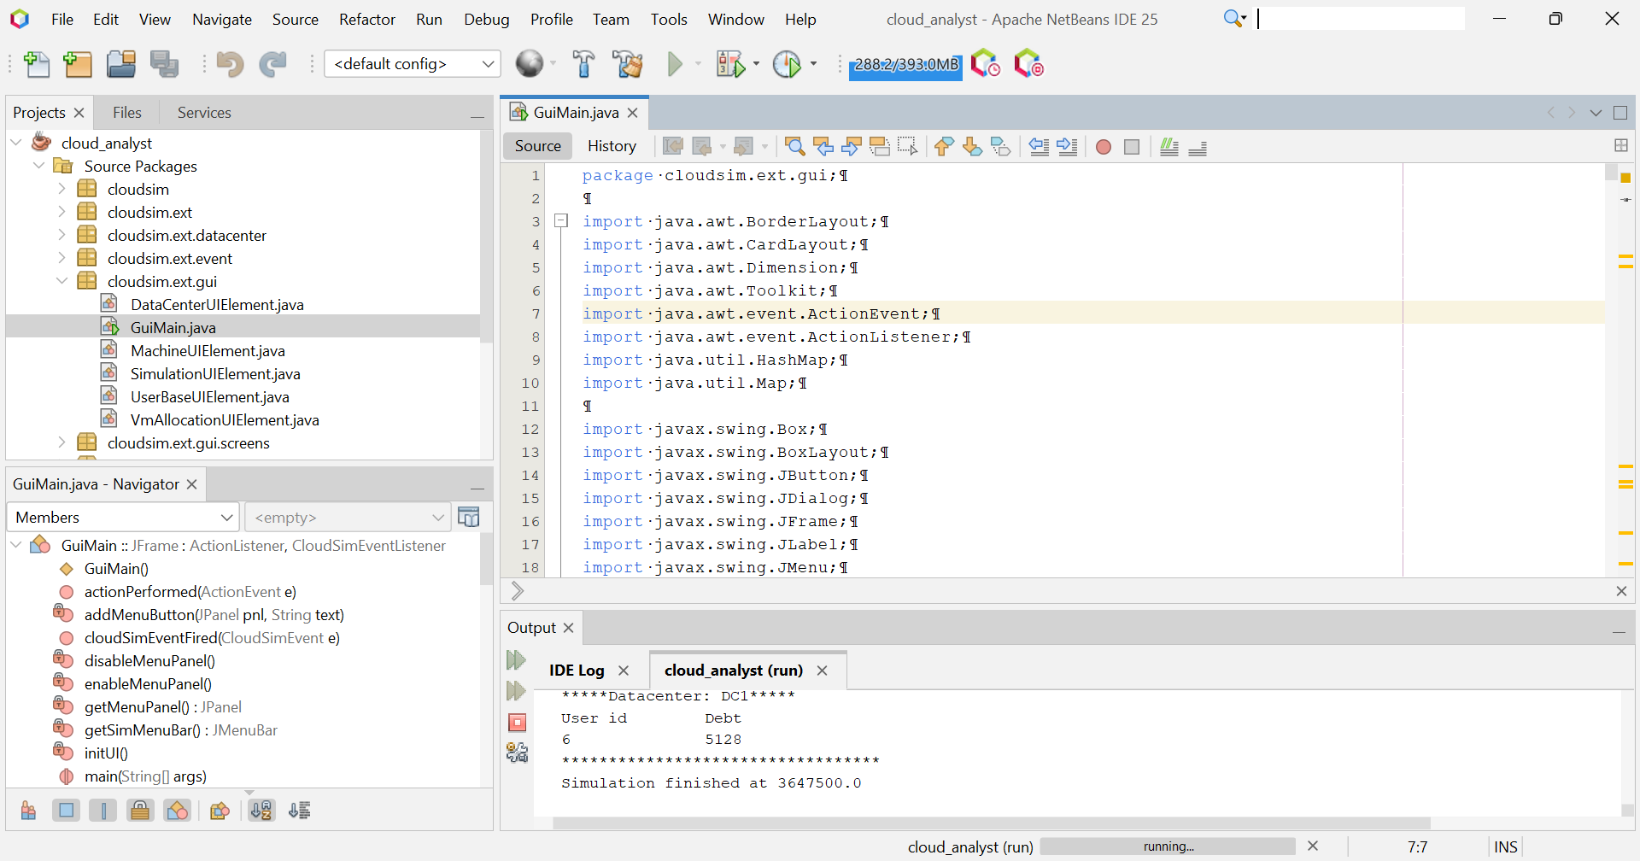

**__________________________________________**

**Steps:**

Download cloud analyst from <https://sourceforge.net/projects/cloudanalystnetbeans/>

Extract cloud analyst in lib folder in C drive

…

…

Complete it by putting snapshots of execution and executing RR algorithm

Configure Cloud analyst

Show simulator output for any one algorithm.

**__________________________________________**

**Post Lab Questions:**

1. **Explain Cloud Analyst Design with a neat diagram.**

The Cloud Analyst architecture is based on CloudSim and consists of multiple layers:

**User Code (Simulation Setup)**

* Defines cloud scenarios, user requirements, and application configurations.
* The User DataCenter Broker manages resource allocation.

**CloudSim Layer**

* Simulates cloud components like Cloudlets (tasks) and Virtual Machines (VMs).

**VM Services**

* Handles cloudlet execution and VM management.

**Cloud Services**

* Manages VM provisioning, CPU, memory, and bandwidth allocation.

**Cloud Resources**

* Includes events handling, cloud coordination, and data centers.

**Network Layer**

* Simulates network topology and message delay for real-world accuracy.

**Core Simulation Engine**

* The backbone that executes, manages, and analyzes cloud performance simulations.

This design helps in analyzing response time, workload distribution, and network performance to optimize cloud computing strategies.

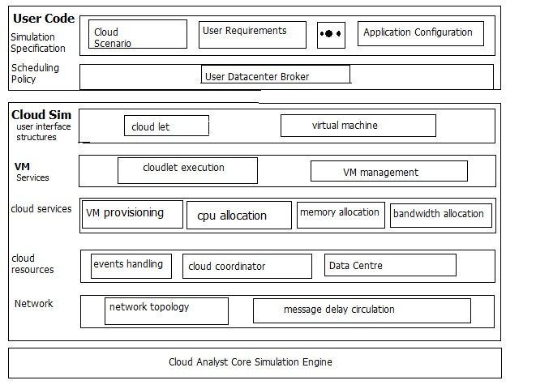

**__________________________________________**

**Outcomes: CO3 – Analyze different cloud architectures and IOT cloud**

**__________________________________________**

**Conclusion: (Conclusion to be based on the objectives and outcomes achieved)**

The experiment successfully demonstrated the use of Cloud Analyst to simulate and evaluate cloud-based application performance. By configuring user bases, data centers, and network parameters, we analyzed key performance metrics such as response time, request processing time, and resource utilization. The graphical output helped in understanding workload distribution and the impact of different scheduling policies on cloud efficiency. This simulation reinforced the importance of cloud architecture, load balancing, and resource allocation in optimizing cloud performance. It provided valuable insights into how user requests are handled, the effect of geographical distribution, and cost implications in cloud computing environments.

**__________________________________________**

**Grade: AA / AB / BB / BC / CC / CD / DD**

**Signature of faculty in-charge with date**

**__________________________________________**

**References:**

**Books/ Journals/ Websites:**

**Cloud Computing Practical 2**

[https://www.youtube.com/watch?v=V6ORsr8Mj4U](http://www.youtube.com/watch?v=V6ORsr8Mj4U)

**__________________________________________**